H.T No
Regulations:
A17


Sreenidhi Institute of Science and Technology
(An Autonomous Institution)
Code No: 6A201 Date: 18-June-2019 (FN)

B.Tech I Year II-Semester External Examination, June-2019 (Supplementary)
CIRCUITS AND NETWORKS – I (EEE)

Time: 3 Hours Max.Marks:75

Note: a) No additional answer sheets will be provided.
b) All sub-parts of a question must be answered at one place only, otherwise it will not be valued.
c) Missing data can be assumed suitably.

Part - A Max.Marks:25

Answer all QUESTIONS.

1. | State Kirchhoff’s laws | [3M]
2. | Derive an expression for equivalent resistance of ‘n’ resistances of value R connected in parallel. | [3M]
3. | Differentiate between planar and non planar graph with suitable example. | [3M]
4. | Define tie set. | [3M]
5. | Define magnetic field intensity. | [3M]
6. | State Faraday’s laws of electromagnetic induction. | [2M]
7. | Define R.M.S value of an alternating quantity. | [2M]
8. | What is quality factor. Explain its significance. | [2M]
9. | State compensation theorem. | [2M]
10. | What is the significance of ‘j’ operator. | [2M]
Part – B Max.Marks:50
ANSWER ANY FIVE QUESTIONS. EACH QUESTION CARRIES 10 MARKS.

11. | a) | Explain the principle of source transformation with a suitable example. | [5M]
 | b) | 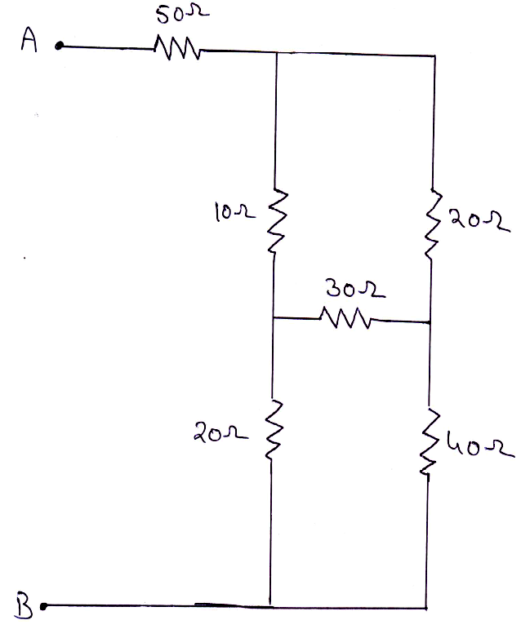  Find the equivalent resistance between the terminals A and B in Figure 1.  Figure 1 | [5M]
12. | a) | Explain the procedure for obtaining fundamental tie–set matrix of a given network. | [5M]
 | b) | Write the basic tie–set schedule for the network shown in Figure 2 by considering 10Ω resistor branches as tree branches.  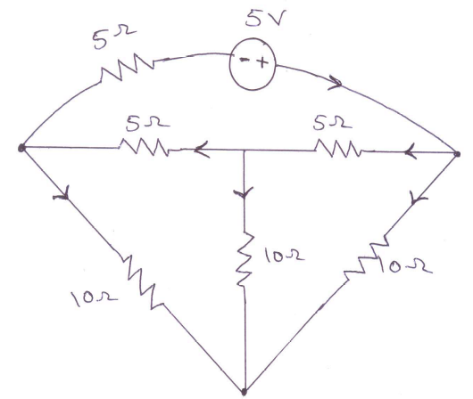  Figure 2 | [5M]
13. | a) | Compare electric and magnetic circuits clearly stating the similarities and dissimilarities between them | [5M]
 | b) | An iron ring of 8cm mean diameter is made up of round iron of diameter 1cm and permeability of 900, has an air gap of 2mm wide. It consists of winding with 400 turns carrying a current of 3.5A. Determine the flux density in the ring. | [5M]
14. | a) | Determine the average value of a half wave rectified sine wave. | [5M]
 | b) | An RC series circuit allows a current i(t) = 10 sin(314t + 60⁰)A to flow from an alternating voltage source v(t) = 200 sin(314t)V. Find the circuit parameters | [5M]
15. | a) | Show that the locus of current in an R–L circuit with variable R is a semicircle. Find the radius and centre of the circle. | [5M]
 | b) | Find the value of C in the circuit shown in Figure 3 such that the circuit resonates at ω = 5000 rad/sec.  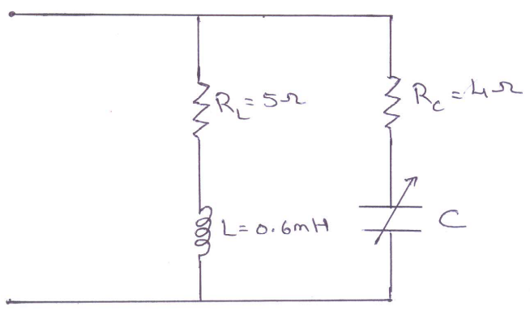  Figure 3 | [5M]
16. | a) | State and explain Thevenin’s theorem. | [5M]
 | b) | 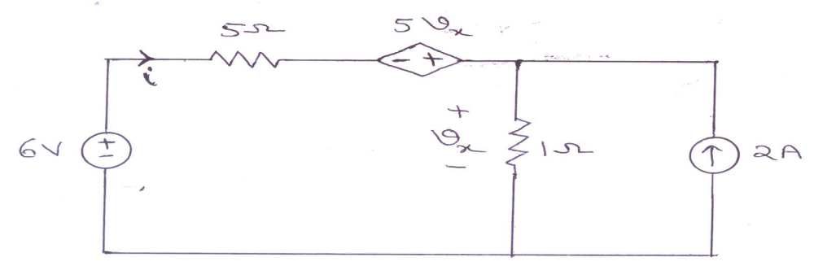  Find the current ‘i’ in the circuit shown in Figure 4 using superposition theorem.  Figure 4 | [5M]
17. | a) | 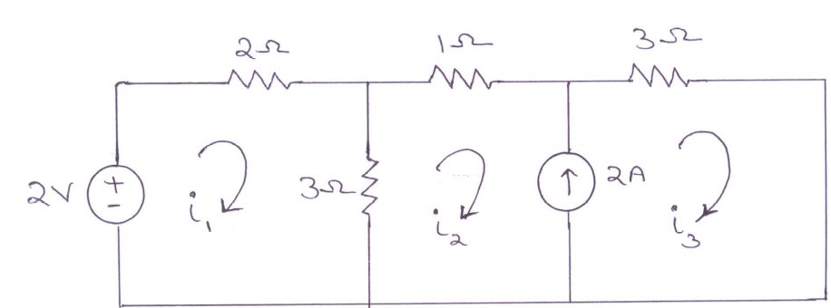  Calculate the mesh currents in the network shown in Figure 5.  Figure 5 | [5M]
 | b) | Two similar coils connected in series give a total inductance of 600mH and when one of the coils is reversed, the total inductance is 300mH. Determine the mutual inductance between the coils and coefficient of coupling. | [5M]
18. | a) | Show that the average power consumed by a pure inductor is zero. | [5M]
 | b) | Using Millman’s theorem, find the current through 10Ω resistor shown in Figure 6.  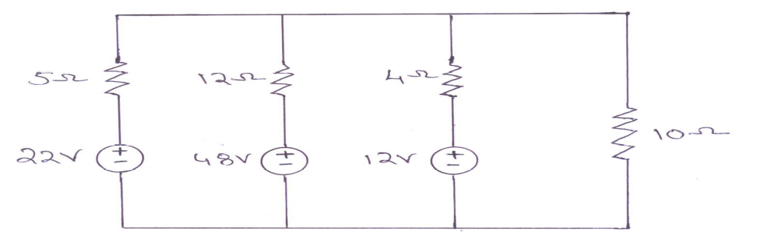  Figure 6 | [5M]

-- 00 -- 00 –

